B302049837

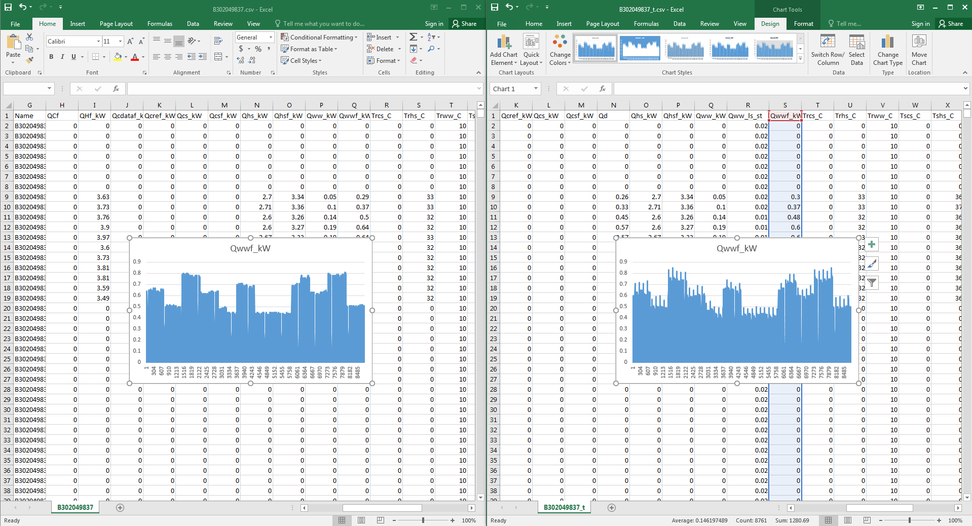 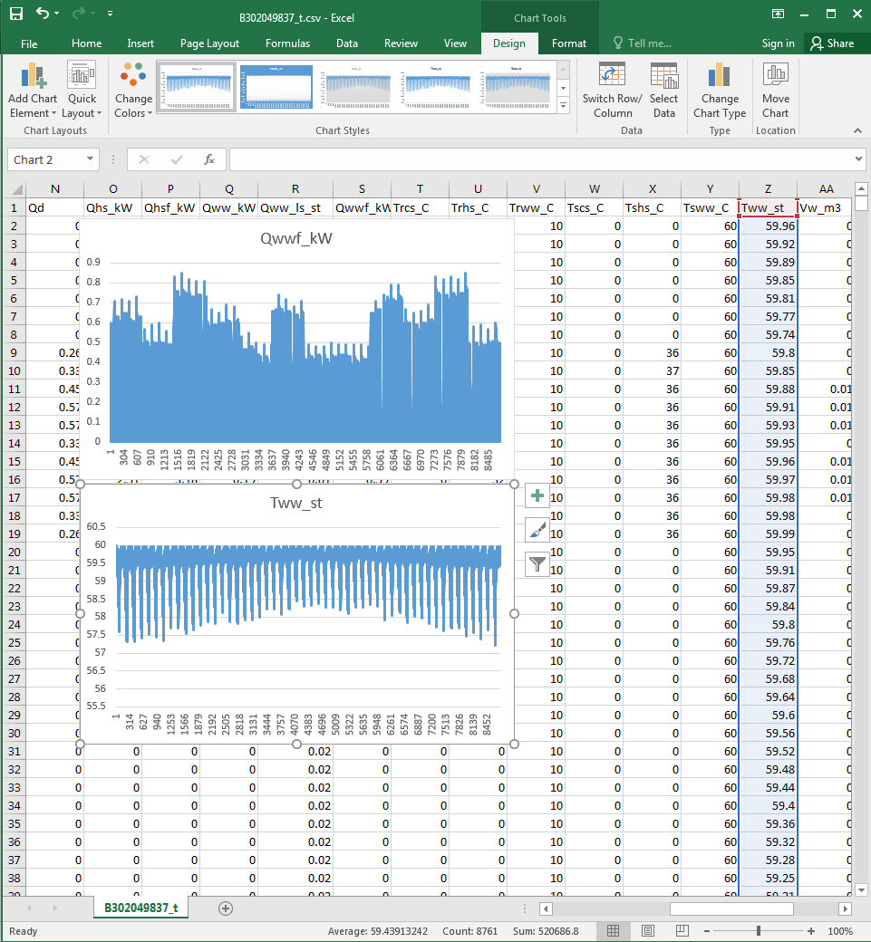

Spiking Qwwf at the beginning of each dhw demand period due to the energy used to compensate storage tank heat loss.

B302049821

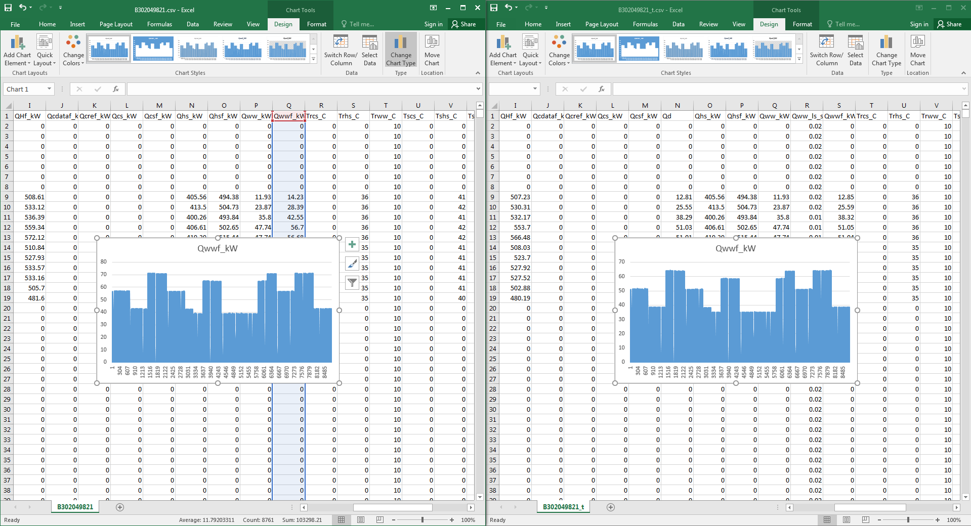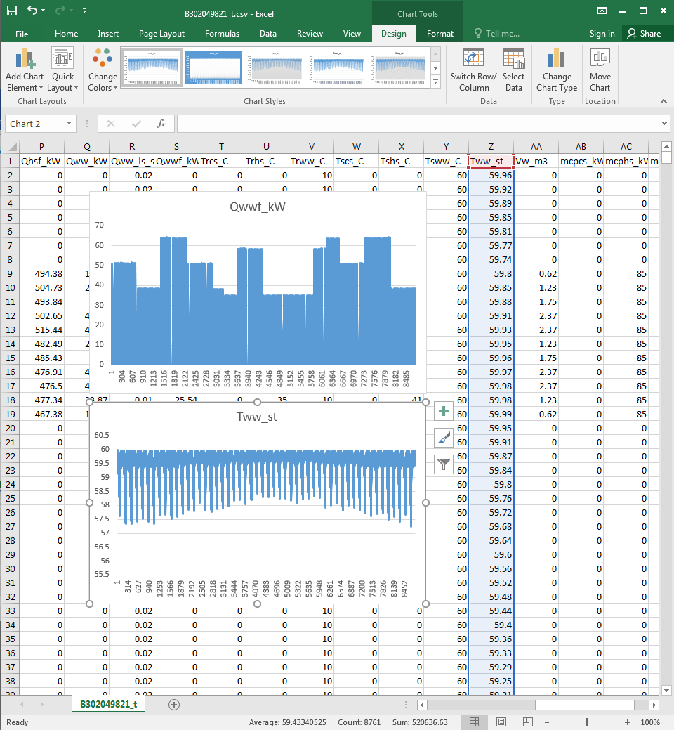

No spiking Qwwf at the beginning of the period since the magnitude of tank heat loss is far lower than dhw demand.

B302049800

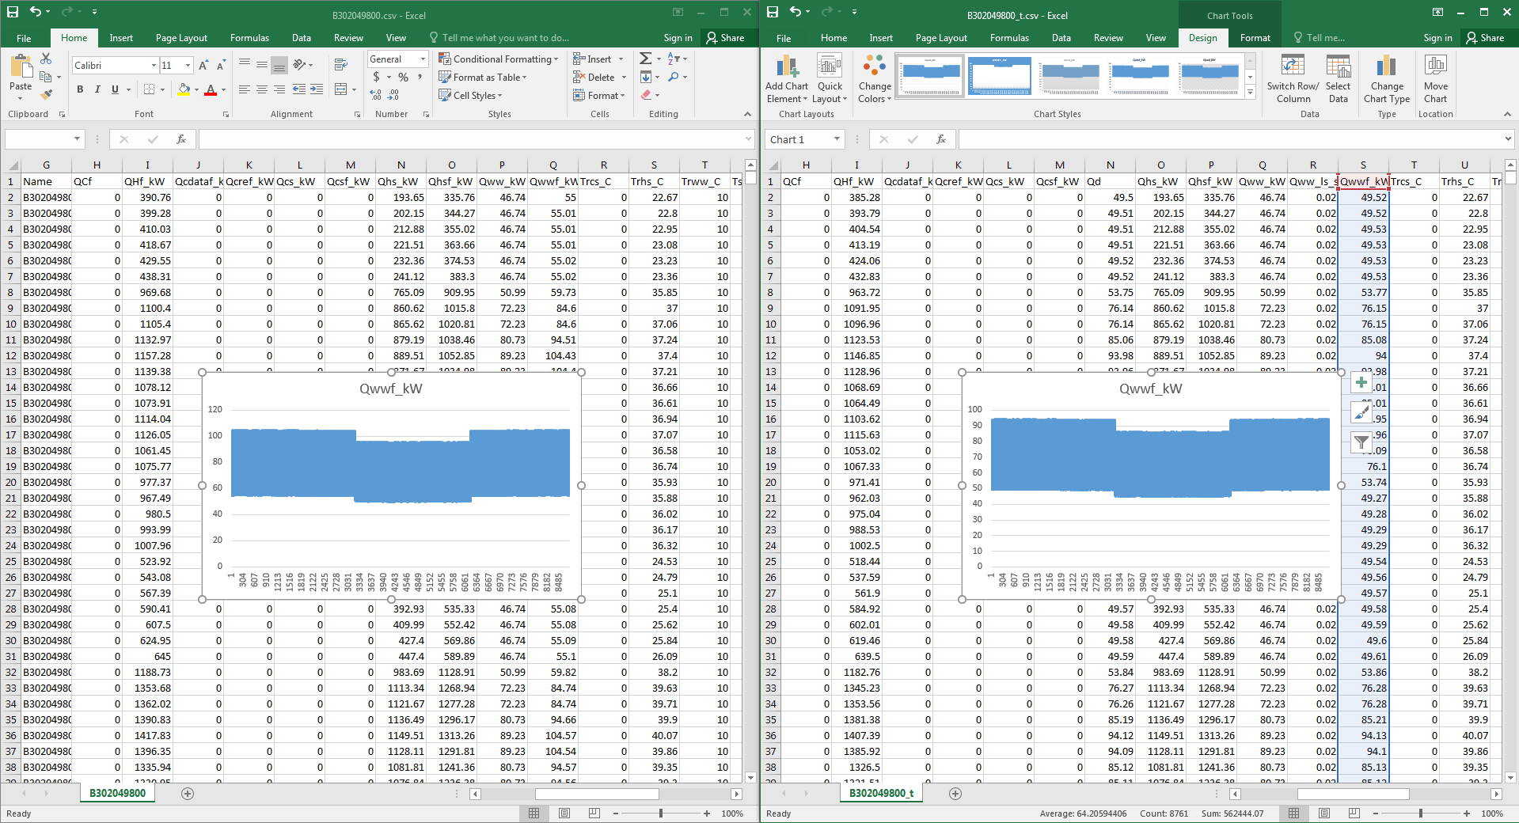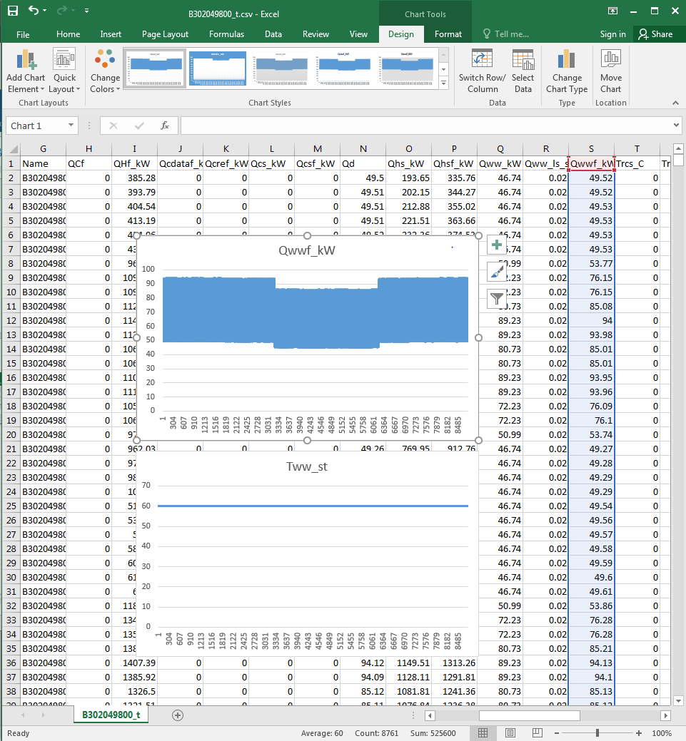

Continuous dhw demand, therefore, tank temperature remains at setpoint temperature.